Network Fundamentals

Linux Fundamentals Part 2

**Task 1:**

No answer needed

**Task 2:**

No answer needed

**Task 3:**

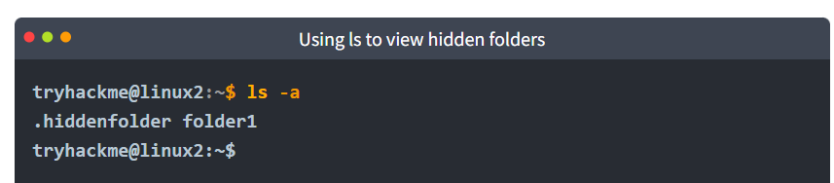

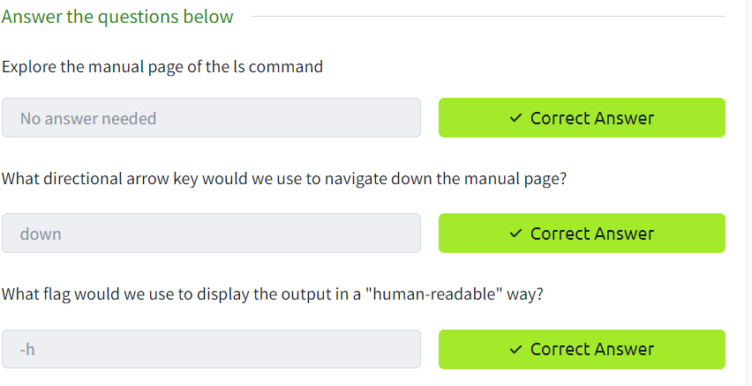

**Task 4:**

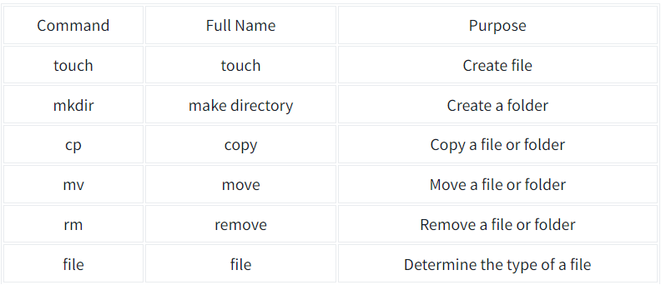

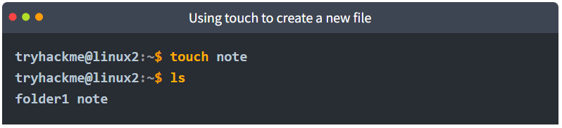

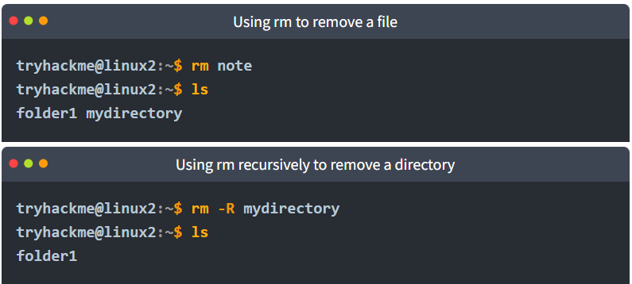

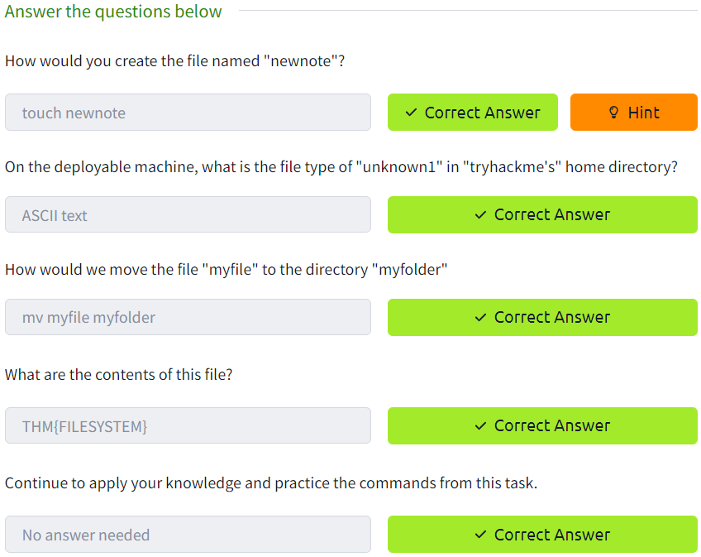

**Task 5:**

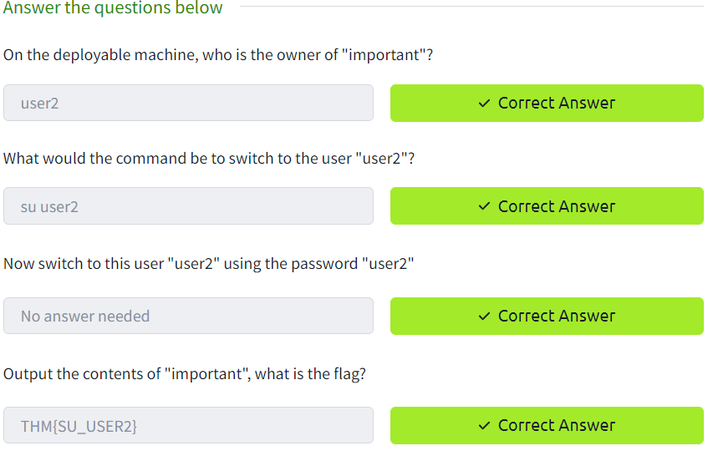

**Task 6:**

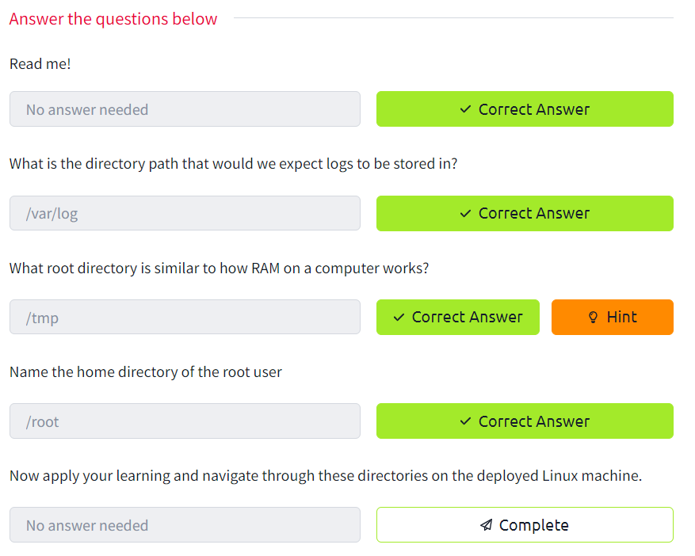

**Task 7:**

**Task 8:**